**[make a copy] Product Requirement Document (PRD) Template**

|  |
| --- |
| All fields are required unless otherwise stated. We will only accept completed PRDs for the pre-review session. |

**Team Sign-offs**

Instruction: The PRD should be reviewed and signed off by your +1's. For a large product feature sign-off from your +2's. For interns, +2's should sign-off and +1's should be in the pre-review meeting. Use the box below to collect their sign-offs.

|  |  |
| --- | --- |
| Button name before click | Click here to sign off this PRD |
| Button name after click | PRD Signed off |
| Button color | GREEN |
| Icon | SELECT |
| Participants |  |

**Summary**

This PRD proposes to build feature X to solve user problem Y.

**Basic Info**

***Change Log***

|  |  |  |
| --- | --- | --- |
| **Date** | **Description** | **By** |
|  |  |  |

***Relevant Links***

|  |  |  |
| --- | --- | --- |
|  | **Links** | **POC** |
| **Link to Meego ticket** | Project (=PRD): | PM |
| **Link to Legal Ticket** |  | Legal |
| **Link to Figma** |  | Design |
| **Link to Starling** |  | Content Designer |
| **Link to Experiment Tracking** |  | DS |
| **Link to Tech Design** |  | RD |
| **Link to QA Checklist** |  | QA |
| **Link to Comm Doc** |  | PSO |

***Authors / Core Team***

|  |  |  |
| --- | --- | --- |
| **Team** | **Role** | **POC** |
| **[Please Add Team Name]** | PM |  |
| PSO |  |
| DS |  |
| RD |  |
| **Ads Interface** | PM |  |
| PSO |  |
| DS |  |
| RD |  |
| QA |  |
| Designer |  |
| Content Designer |  |

|  |
| --- |
| Rough Sizing (*Sizing is determined based on 3 criteria. Select 1 choice under each criteria)* |

|  |  |  |  |  |
| --- | --- | --- | --- | --- |
| **Engineering Effort** |  | **Revenue Impact \*** |  | **UX Effort** |
| * X-Large;   >4 weeks for 1 RD | * X-Large;   Opens significant new market opportunity | * X-Large;   >4 weeks for 1 designer;  Complete redesign of core user experience |
| * Large;   2-4 weeks for 1 RD | * Large;   Major revenue impact (P0 project) | * Large;   2-4 weeks for 1 designer;  Major changes to core features |
| * Medium;   1-2 week for 1 RD | * Medium;   Moderate revenue impact (non-P0 project) | * Medium;   1-2 week for 1 designer;  Noticeable changes for regular users |
| * Small;   <= 1 week for 1 RD | * Small;   No measurable revenue impact | * Small;   <= 1 week for 1 designer;  Minimal changes, likely unnoticed by most users |

*\*Note: Consider revenue impact in both the immediate and long term.*

**Problem Statement**

**Target Users**

* Who is the customer?
* How many advertisers will use this feature in the first 3 months?
* [Optional] Sometimes it helps to also state "whose problem are we leaving out?"
* [Optional] Do we anticipate any trade-offs?

**User Problems**

* What problems/opportunity are we solving for the target users?
* [Optional] Quantitative or qualitative evidence supporting the problem statement.
* [Optional] Out of scope: anything that is left out.

**Impact**

* How do we know this is an important problem/opportunity?
* *Clearly articulate the insights through user research or customer feedback.*
* What will be the impact on success metrics?
* *Work with your DS team to clearly articulate the impact on your success metrics, backed with actual calculation.*

**Alpha & Beta Test Results / Supporting Research**

* Include alpha or beta test results in this section to help us prioritize your request. Please include supporting research for requests that require development before alpha or beta testing.

**Success Metrics**

|  |
| --- |
| *Please work with your DS partners to review the success metrics and identify 1-2 metrics. Avoid listing a bunch of metrics as success metrics.* |

* North Star Metrics
* [Optional] Guardrail Metrics

|  |  |
| --- | --- |
| Button name before click | Mark as Read |
| Button name after click | Marked as Read |
| Button color | GREEN |
| Icon | SELECT |
| Participants |  |

**Proposed Solution / Requirement Details**

**User Interaction & Design**

|  |  |  |  |
| --- | --- | --- | --- |
| **Scenarios** | **Current version** | **Proposed version** | **Error States / Edge Cases** |
|  |  |  |  |

**Impact on other flows or horizontal modules (if applicable)**

*Please outline the potential impact or divergence this proposal will have on other flows and modules.

|  |  |  |
| --- | --- | --- |
| **Scenarios** | **Current version** | **Proposed version** |
|  |  |  |

**Proposed Launch Plan**

**User Behavior Event Logging**

Lorem ipsum

**Platform Experiment Design**

|  |  |  |  |
| --- | --- | --- | --- |
| **Group** | **Traffic Allocation** | **Treatment (what's different)** | **Design** |
| v1 (Control) |  |  |  |
| v2 |  |  |  |

**Checklist**

**Compliance & Safety**



**Click the image to view the sheet.**

**Platform/Product(s)**

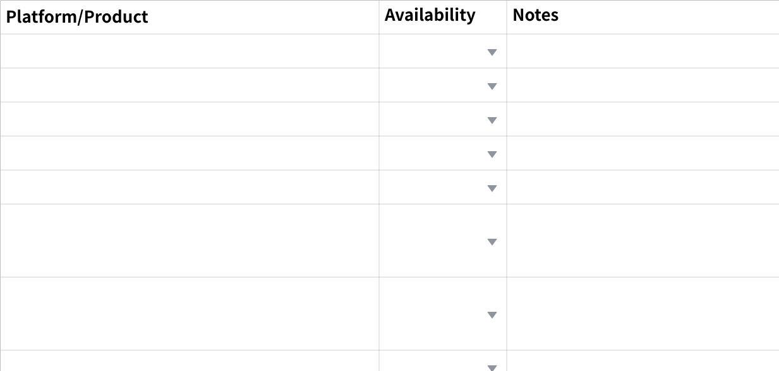

**Click the image to view the sheet.**

**Objectives & Buying Type**

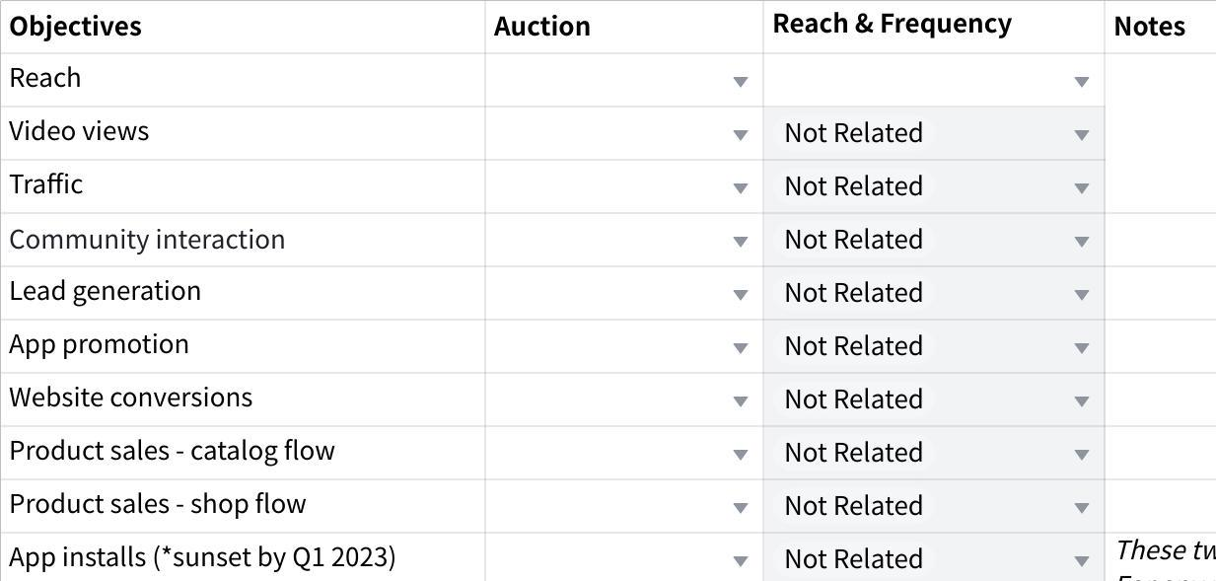

**Click the image to view the sheet.**

**Placements**

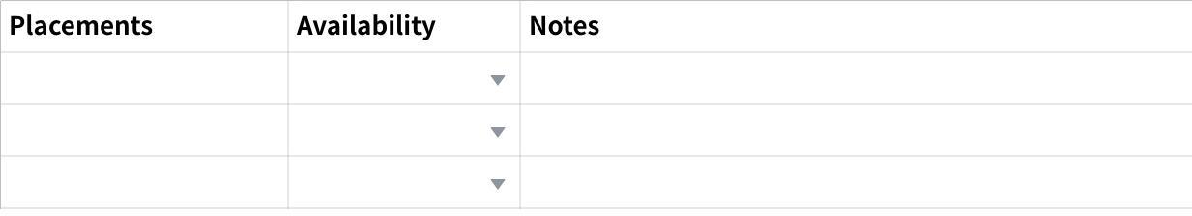

**Click the image to view the sheet.**

**TTAM Platform Modules**

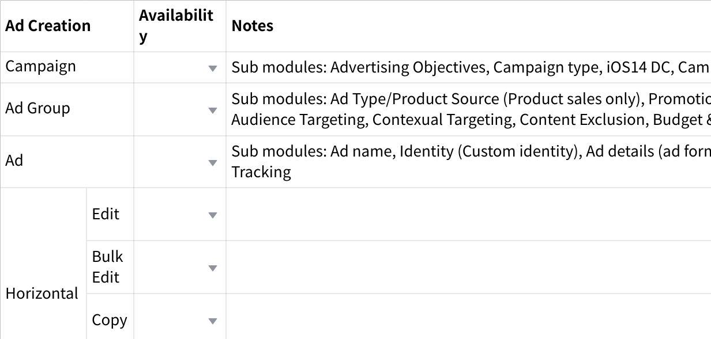

**Click the image to view the sheet.**

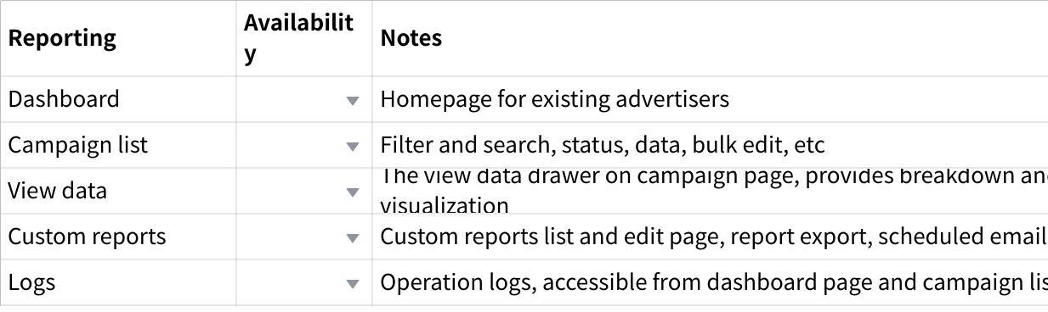

**Click the image to view the sheet.**

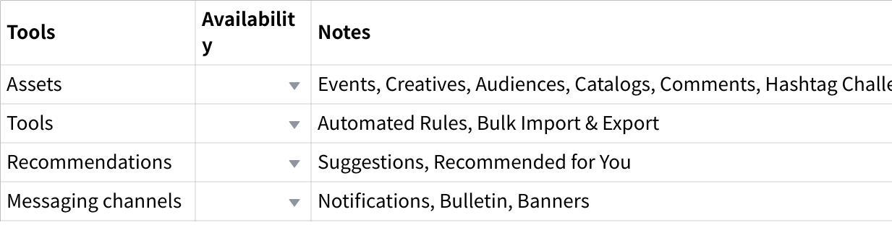

**Click the image to view the sheet.**

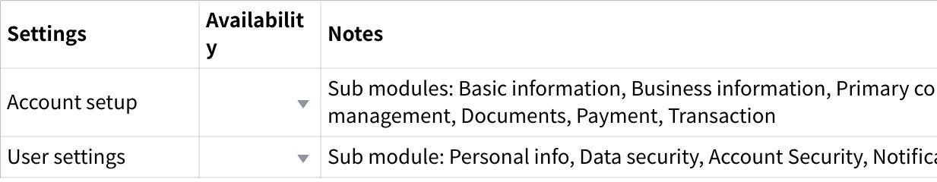

**Click the image to view the sheet.**

**Appendix**

* **Brainstormed Ideas & Options Considered** *- Link to References / Screenshot*
* **Competitors & Product Inspiration** *-**Link to References / Screenshot*
* **Future Work** *- List follow-up features if there are any*
* **Meeting Notes** *- Update discussion notes from alignment meetings if there are any*